

**INDIAN INSTITUTE OF INFORMATION TECHNOLOGY, NAGPUR**

C/o Regional Telecom Training Centre (RTTC) BSNL, Seminary Hills, Nagpur-440006 091-0712-2801369, Email: registrar@iiitn.ac.in

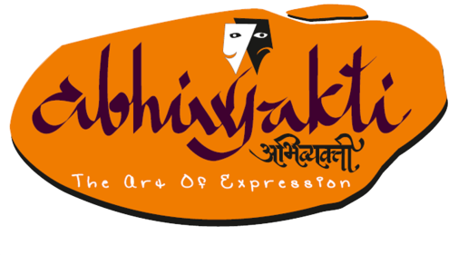---------------------------------------------------------------------------------------------------------------------------------------------------

Presents Prashna Baan

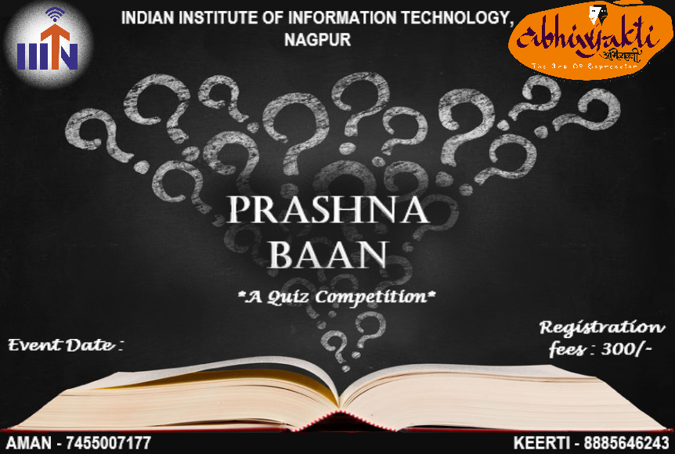

**About the Event:**

Prashna Baan is a quiz competition of, the annual cultural fest of IIIT Nagpur, Abhivyakti. A quiz is a form of game or mind sport, in which the players (as individuals or in teams) attempt to answer questions correctly. It is a game to test your knowledge about a certain subject or over a range of subjects.

**GENERAL RULES:**

* Participants must possess a valid proof of successful registration for the event. (Can register by visiting (www.website.com)
* Participants must possess a valid college identity card of their institution. And only registered people are allowed to take part in the event.
* A maximum of 3 persons are allowed per team.
* Use of any electronic gadgets by participants will not be encouraged.
* The questions shall be in the form of multiple choice, specific answer questions etc,.
* The decision of the Quiz Master will be final and binding.
* You need to get ready at least 10 minutes before the event starts.
* Every participant(s) are required to fill up the “undertaking”.
* **Please, do collect your identity cards available at the registration desk.**

**Note**: In case of any discrepancy decision of Team Abhivyakti will be final.

**REGISTRATION FEES:** 300/- per team

**Prizes:**

**1st Winner : INR 3000\***

**2nd Winner : INR 2000\***

**Contact Us:**

Keerti Bajaj : 8885646243

Aman Soni : 7455007177